Week- 6 Skill
- To Store Commands, Maintain History Buffer, Handle Capacity Limits, Retrieve Entries, Display History, Validate Consistency
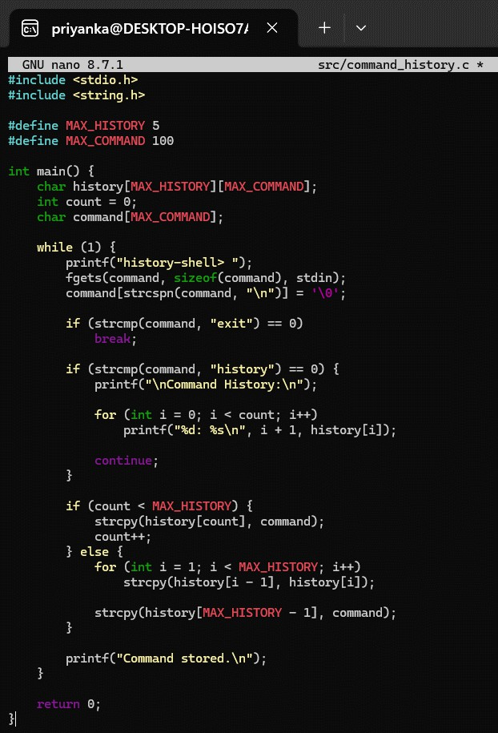
Output:
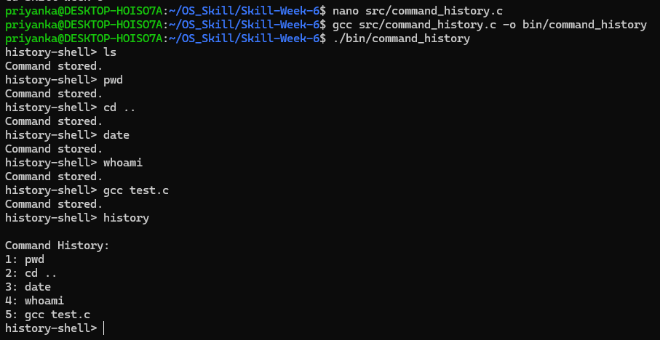

- To Create Pipeline Structures, Store Commands, Maintain Execution Order, Connect Processes, Validate Pipeline Layout, Test Configurations
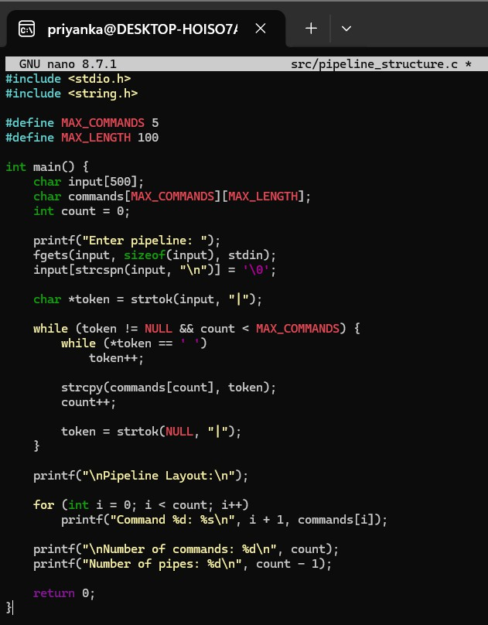
Output:
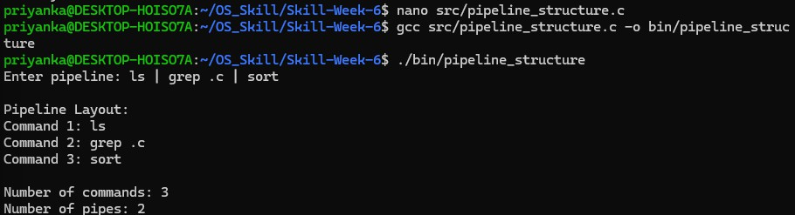

- To Create Pipes, Redirect Streams, Execute Connected Commands, Close Descriptors, Synchronize Processes, Test Data Flow
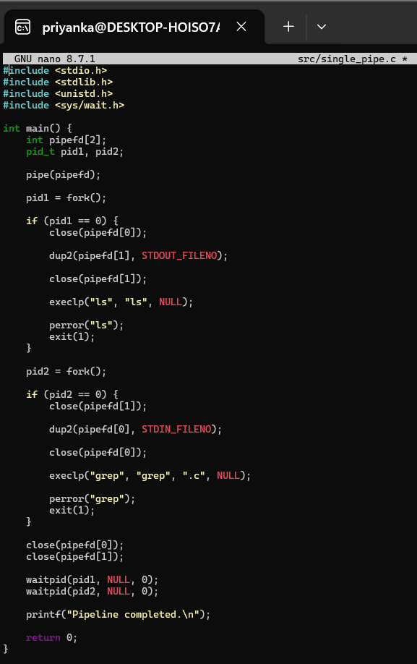
Output:
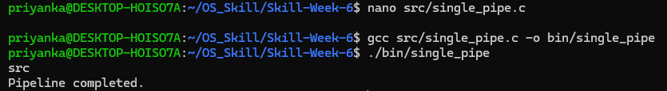

- To Support Multiple Pipes, Manage Descriptor Arrays, Launch Multiple Processes, Coordinate Execution, Cleanup Resources, Test Long Pipelines
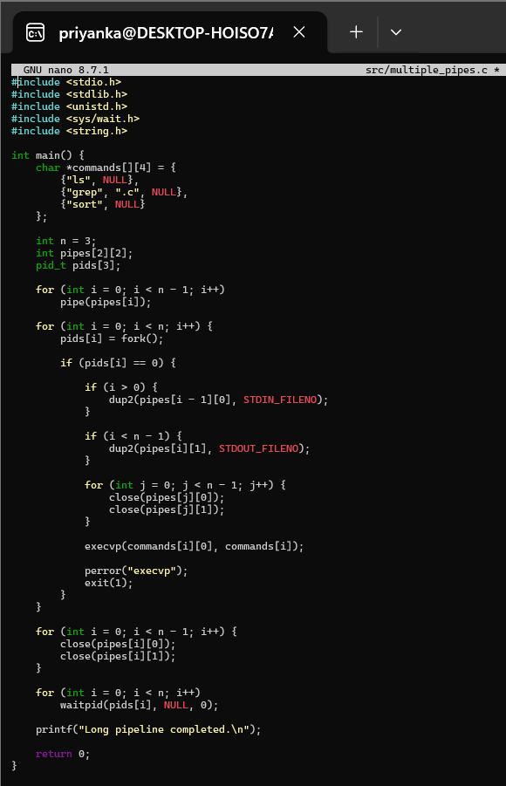
Output:
